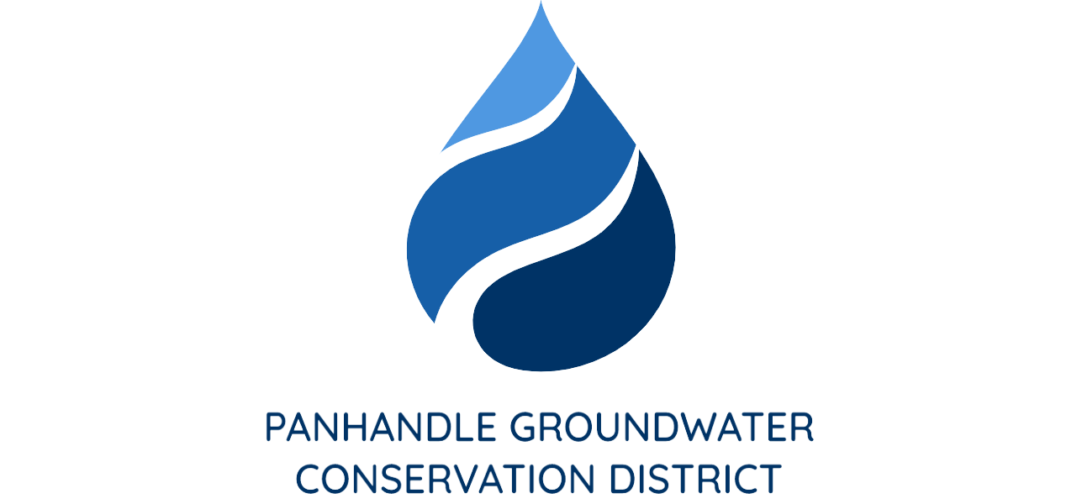

PRESS RELEASE
Contact: Britney Britten, General Manager
Panhandle Groundwater Conservation District
(806) 883-2501
britney@pgcd.us

FOR IMMEDIATE RELEASE

Panhandle Groundwater District Scholarship Opportunity

WHITE DEER, TX. (January 10, 2023) – Since 2002, Panhandle Groundwater Conservation District (PGCD) has provided $180,000 in scholarship funds to deserving high school seniors in our District. The scholarship is based off grades, extracurricular activity involvement, financial need and an essay with the topic provided by the District.

2022-2023 Essay Topic:

How may ways do we rely on water in our community? Consider municipal, agricultural, and industrial uses.

The last day to submit an application is Friday, March 10th. More information on how to apply, guidelines and eligibility can be found on the District’s website at www.pgcd.us or by calling Aspen Edgar at 806-883-2501.

